**Linux and Cloud Computing Module Exam**

**Cloud Computing :-**

**Question Part 1)**

**Solution)**

STEP 1) Created a user

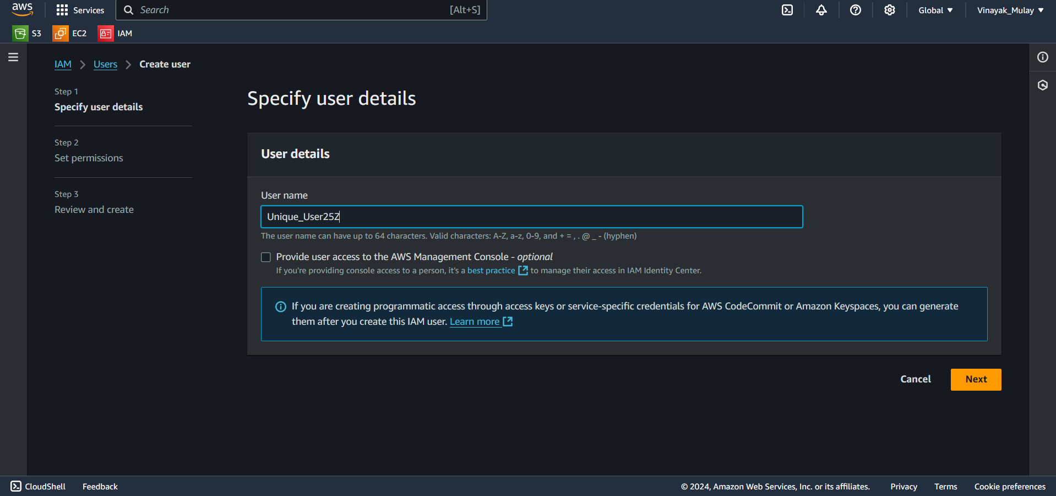

STEP 2) Enabling attach policies for the new user.

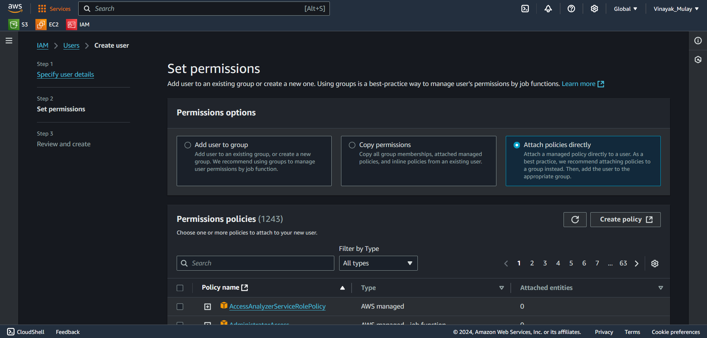

STEP 3) Ensured that user has a policy granting EC2_Full_Access.

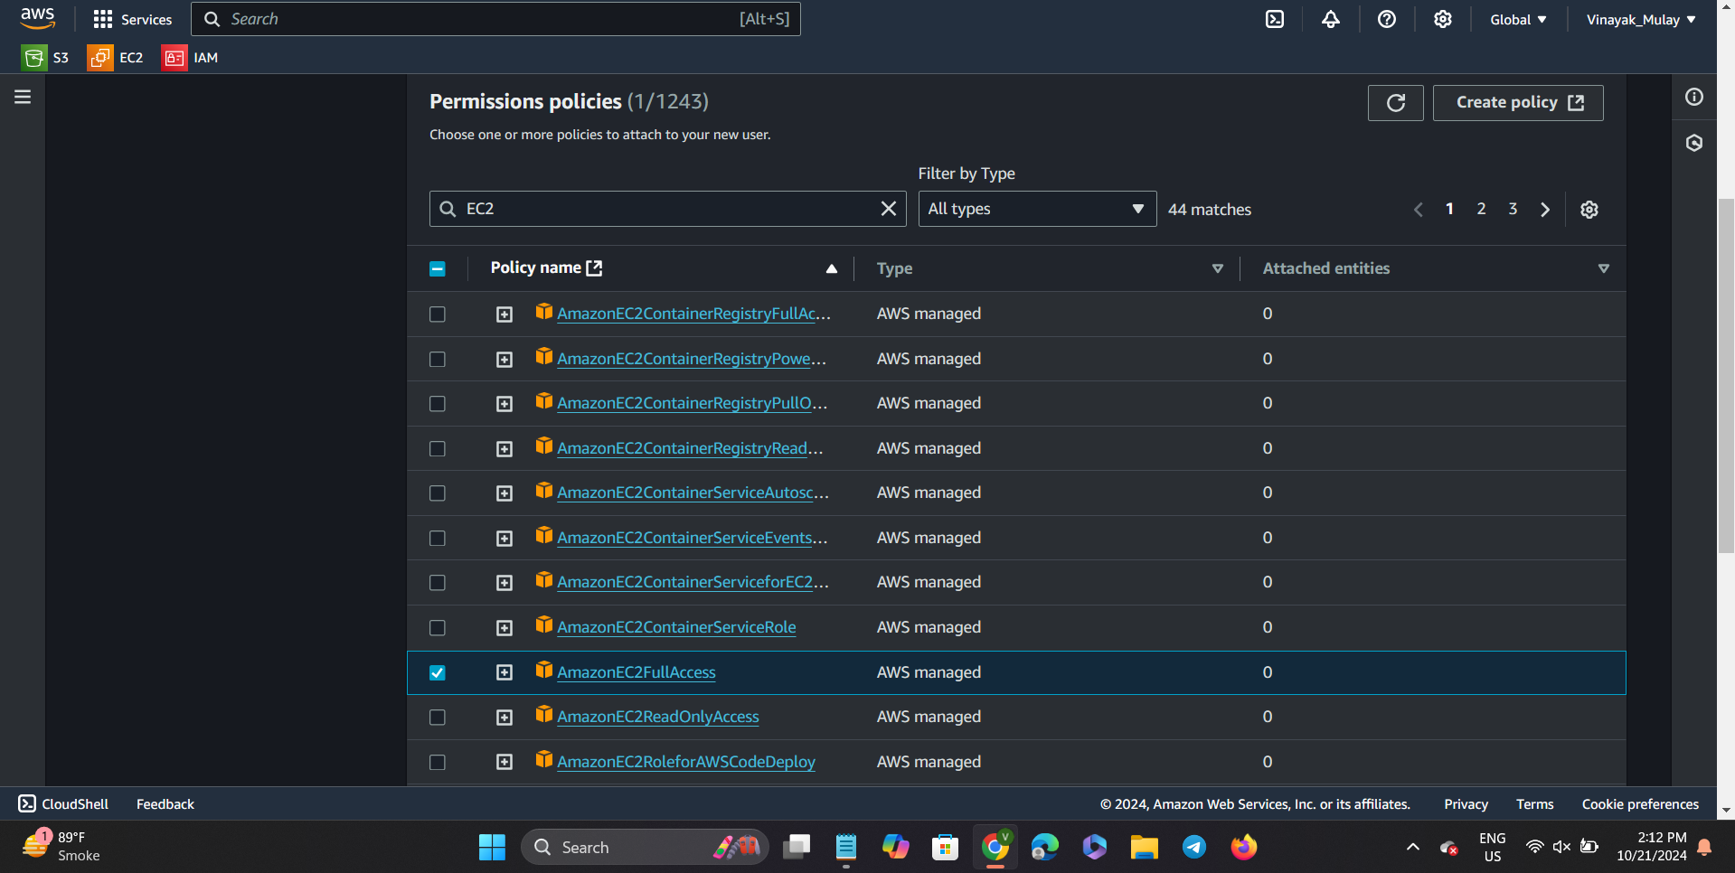

STEP 4) Click on the next button in the right bottom corner.

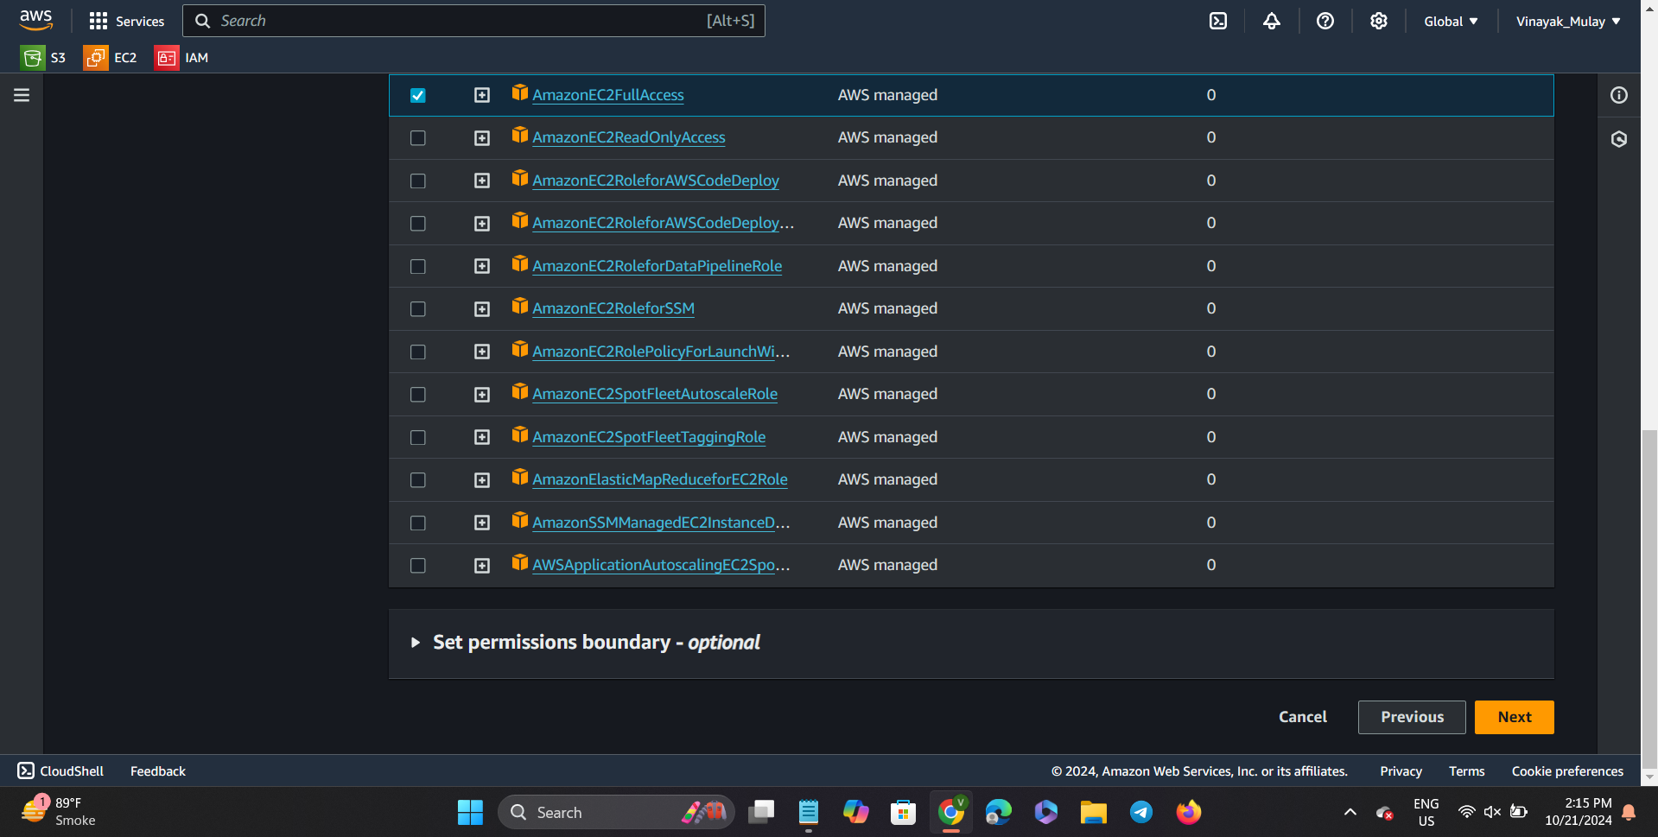

Step 5) Below screenshot mentions all the permissions granted to new unique user. And then click on the create user button.

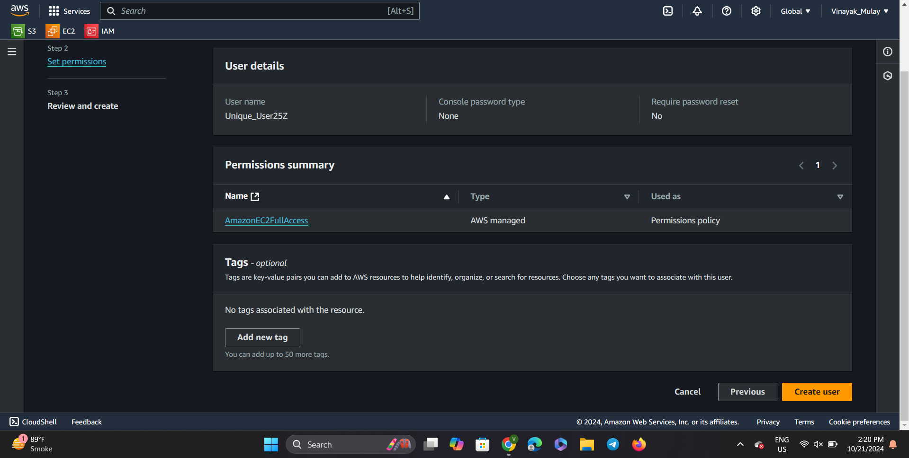

Step 6) A new user has been created.

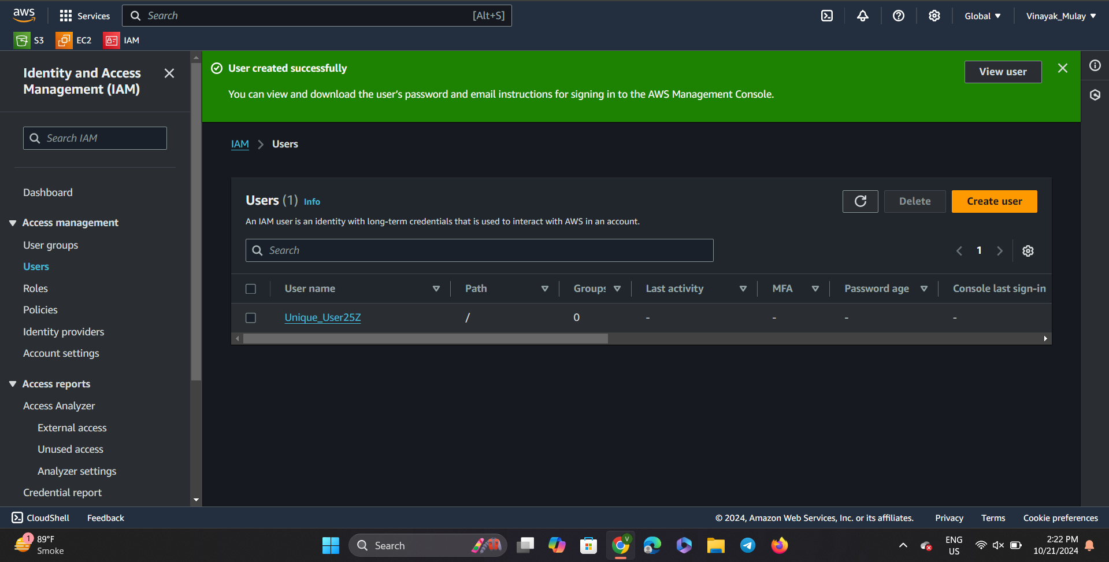

Step7) A unique user has been created with a granting policy of EC2 Full Access.

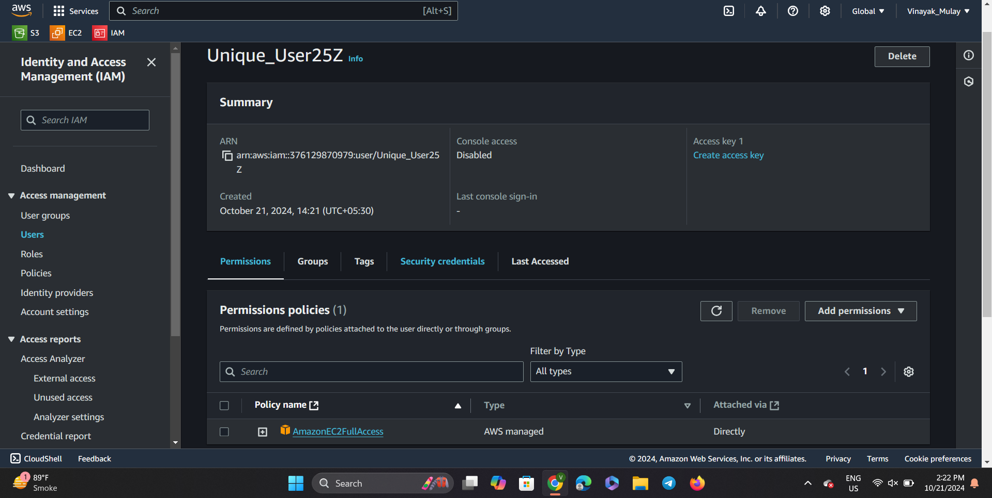

Cloud Computing Question Part 2)

Step1)We will go to IAM menu.

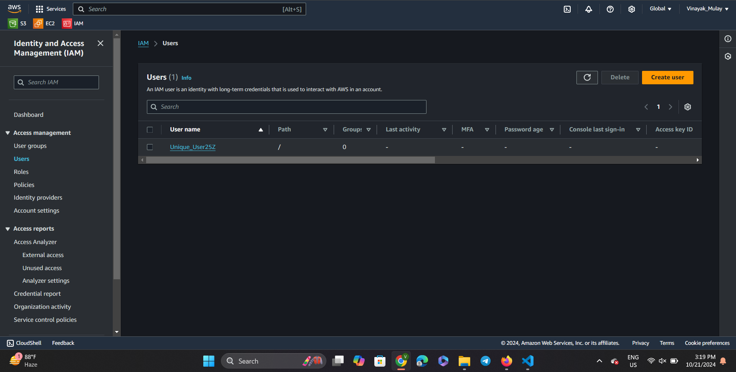

STep2) Now we will click on our new users profile.

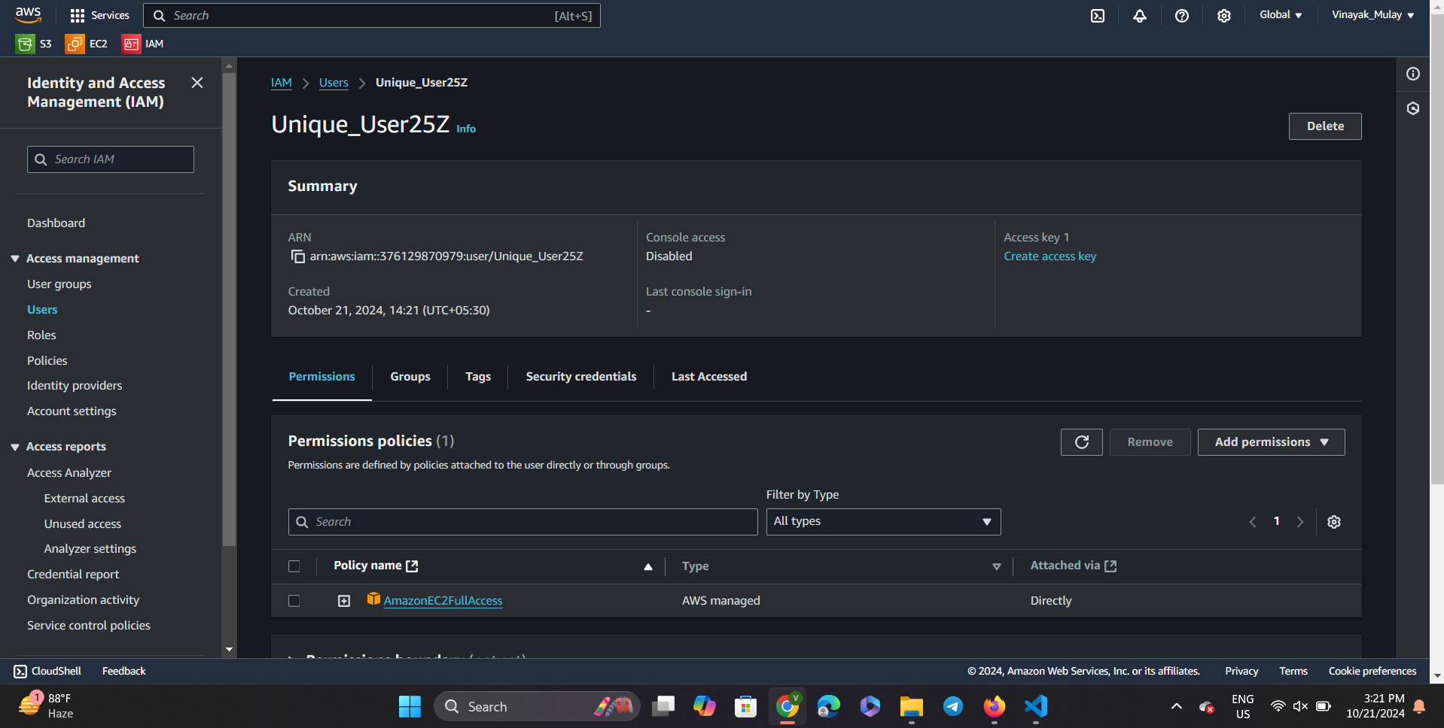

Step 3) Now we will go to security credentials.

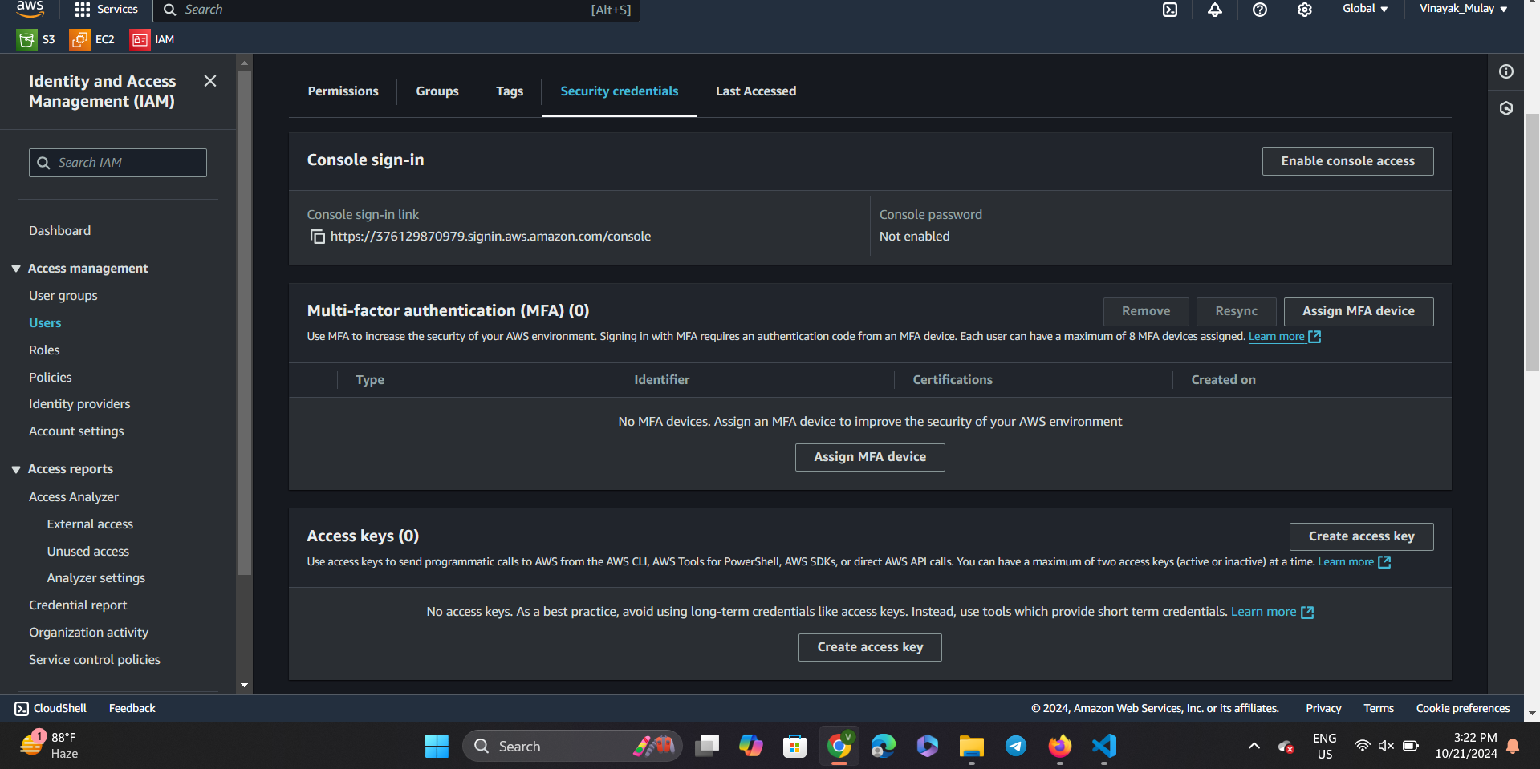

Step 4)We will click on enable console access.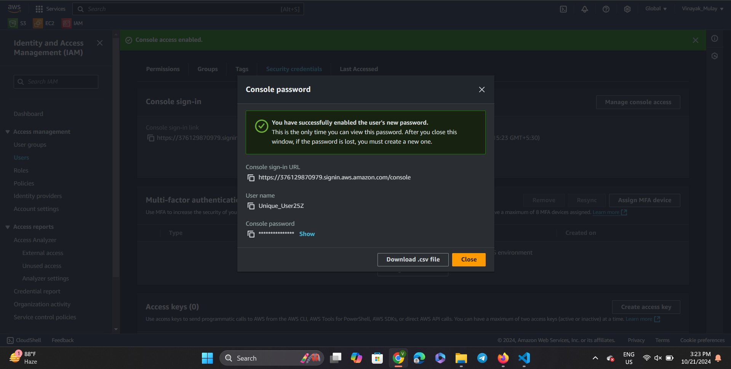

Step 5) We will download CSV file of username and password.

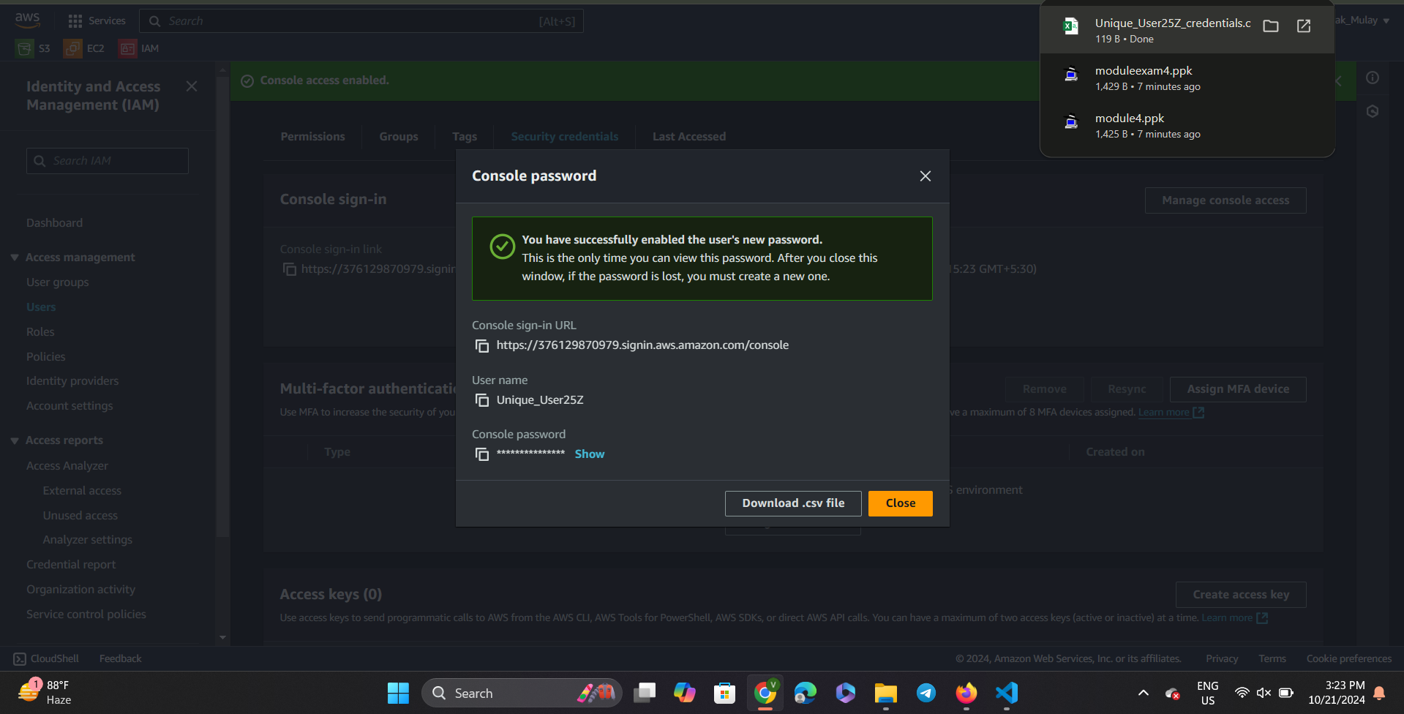

Step6) Then we will go to enable console access and click on next after selecting the above below choices.

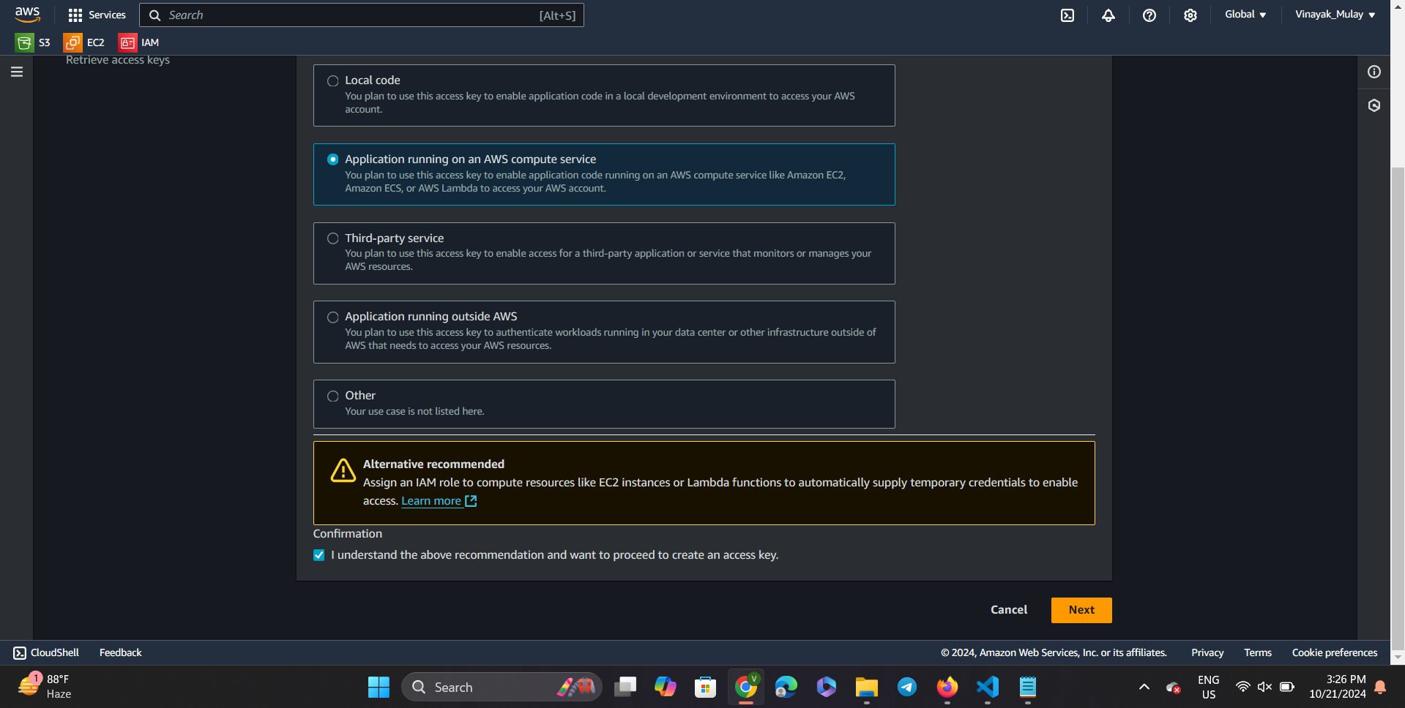

Step7) CLick on create access key.

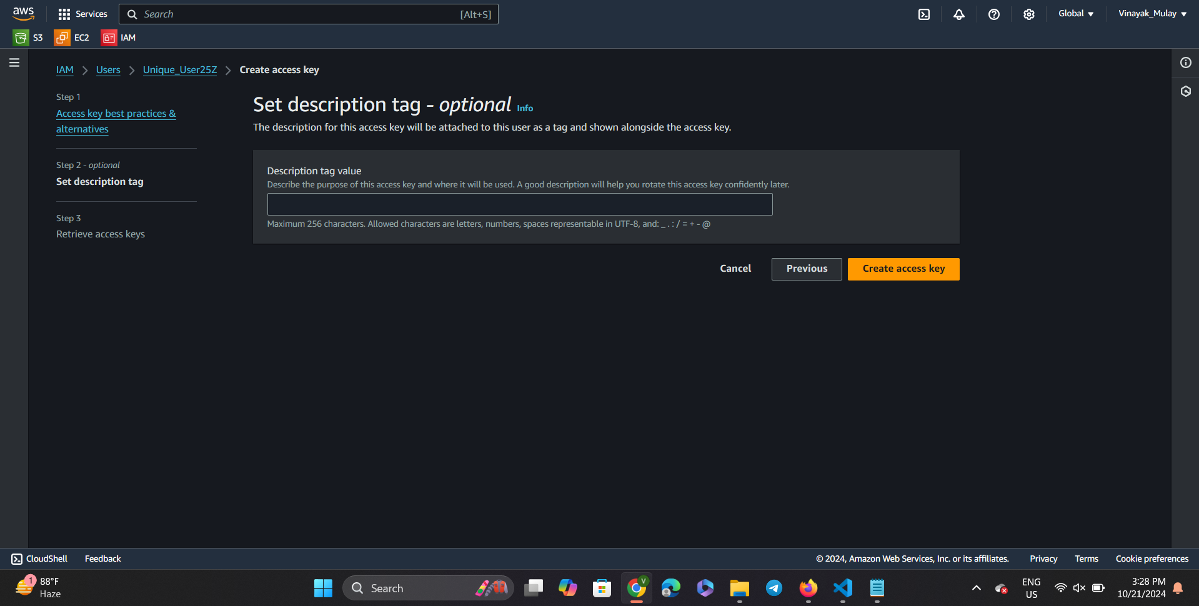

Step 8) And the copy both the given keys.

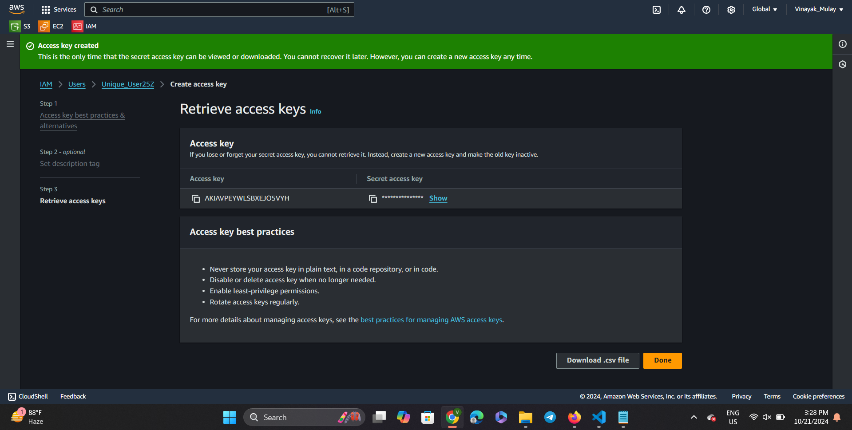

Step 9)

Cloud computing question part 3)

Step 1) Go to the search bar in AWS id and search for S3 and click on S3.

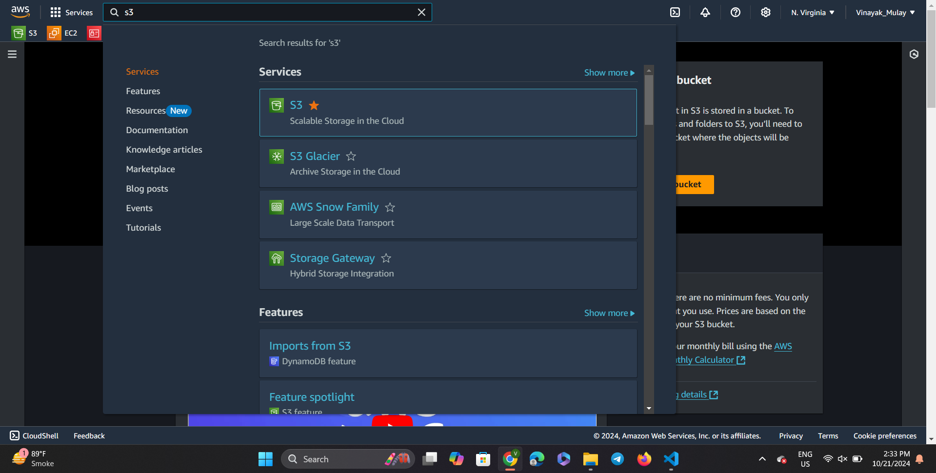.

Step2) In the next window click on the “Create bucket button”.

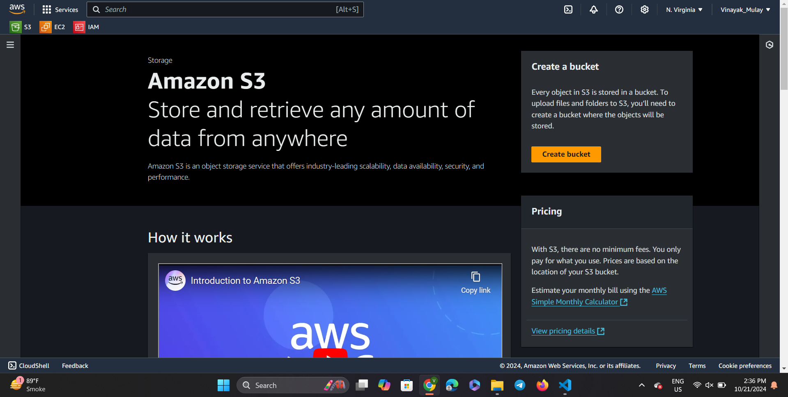

Step 3) Once you get to the “create bucket” page, pick a name for your new bucket and scroll down to carry on with the process.

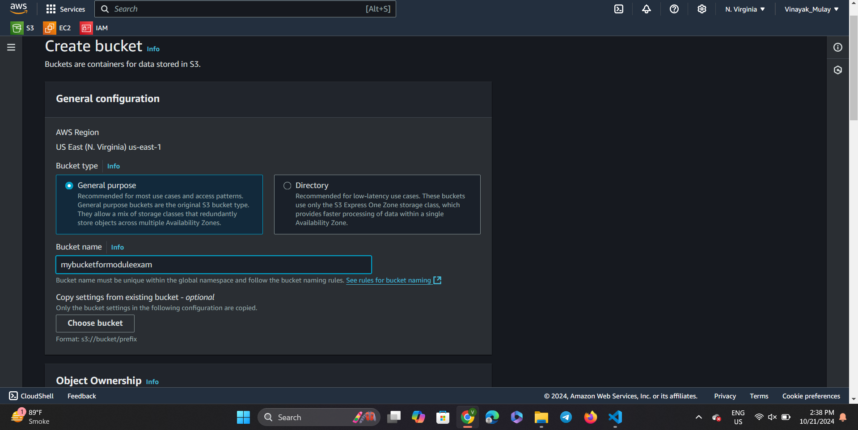

Step 4)Next change the object ownership default choice to “ACLs enabled” and scroll down to continue further with the process of bucket creation.

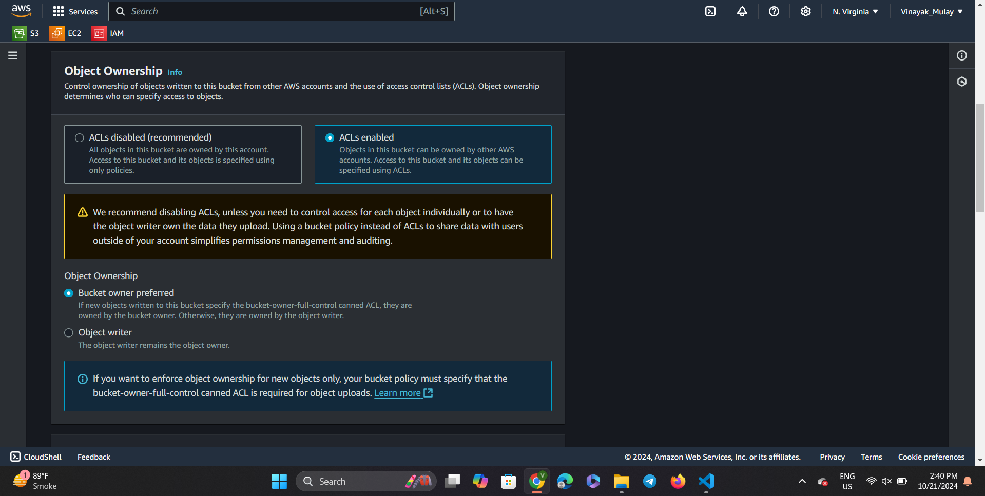

Step5) Uncheck to block all public access radio button.

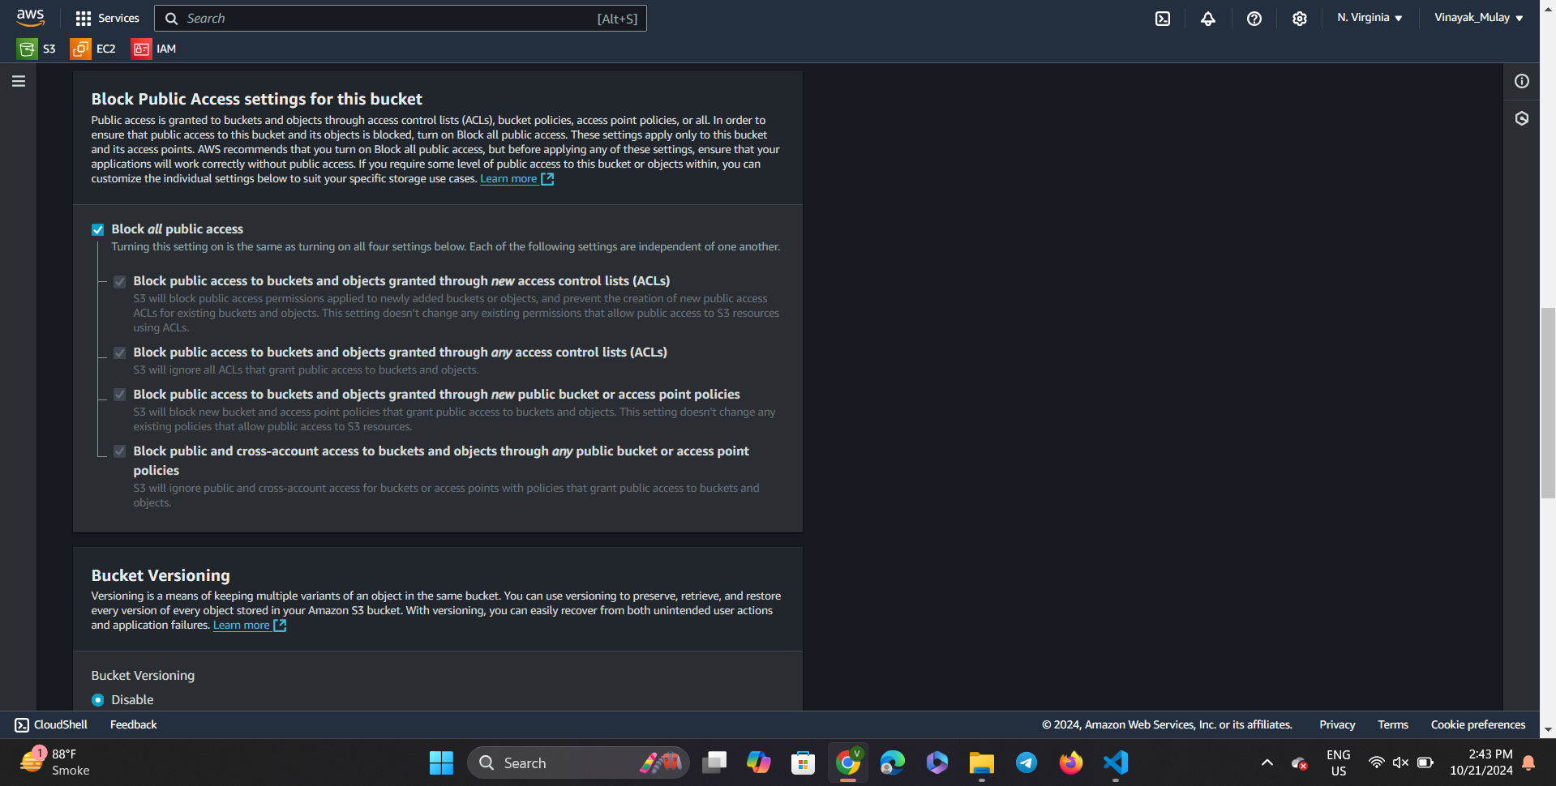

Step6) And then select to the acknowledgement given in the warning cell present at the bottom of the Block Public access settings.

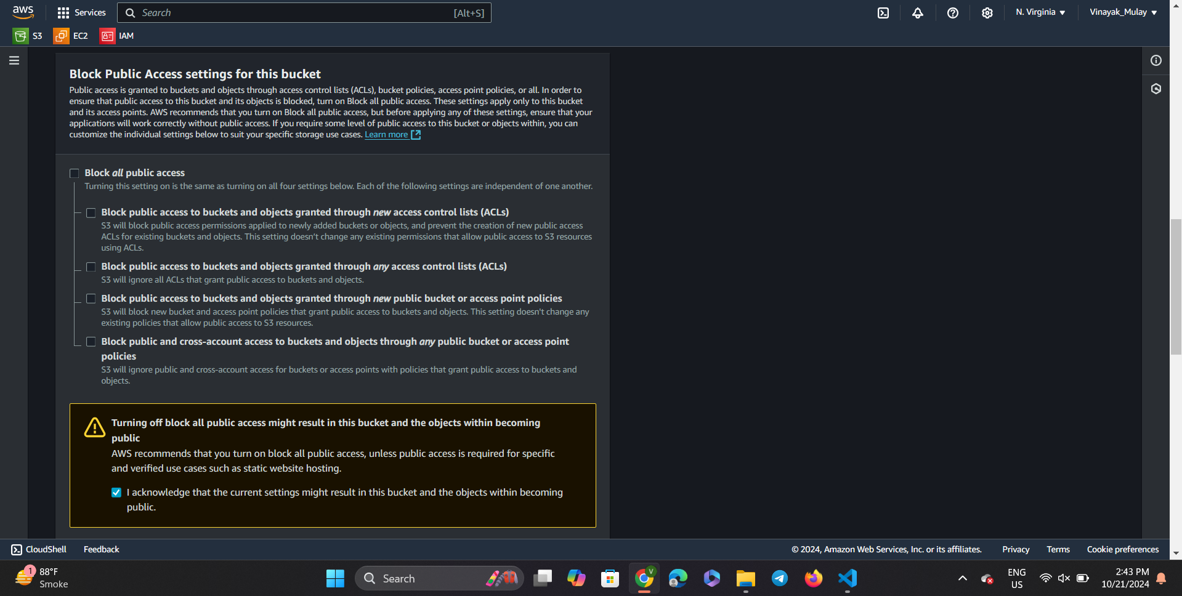

Step 7) Next, enable the bucket versioning and scroll to the bottom of the page.

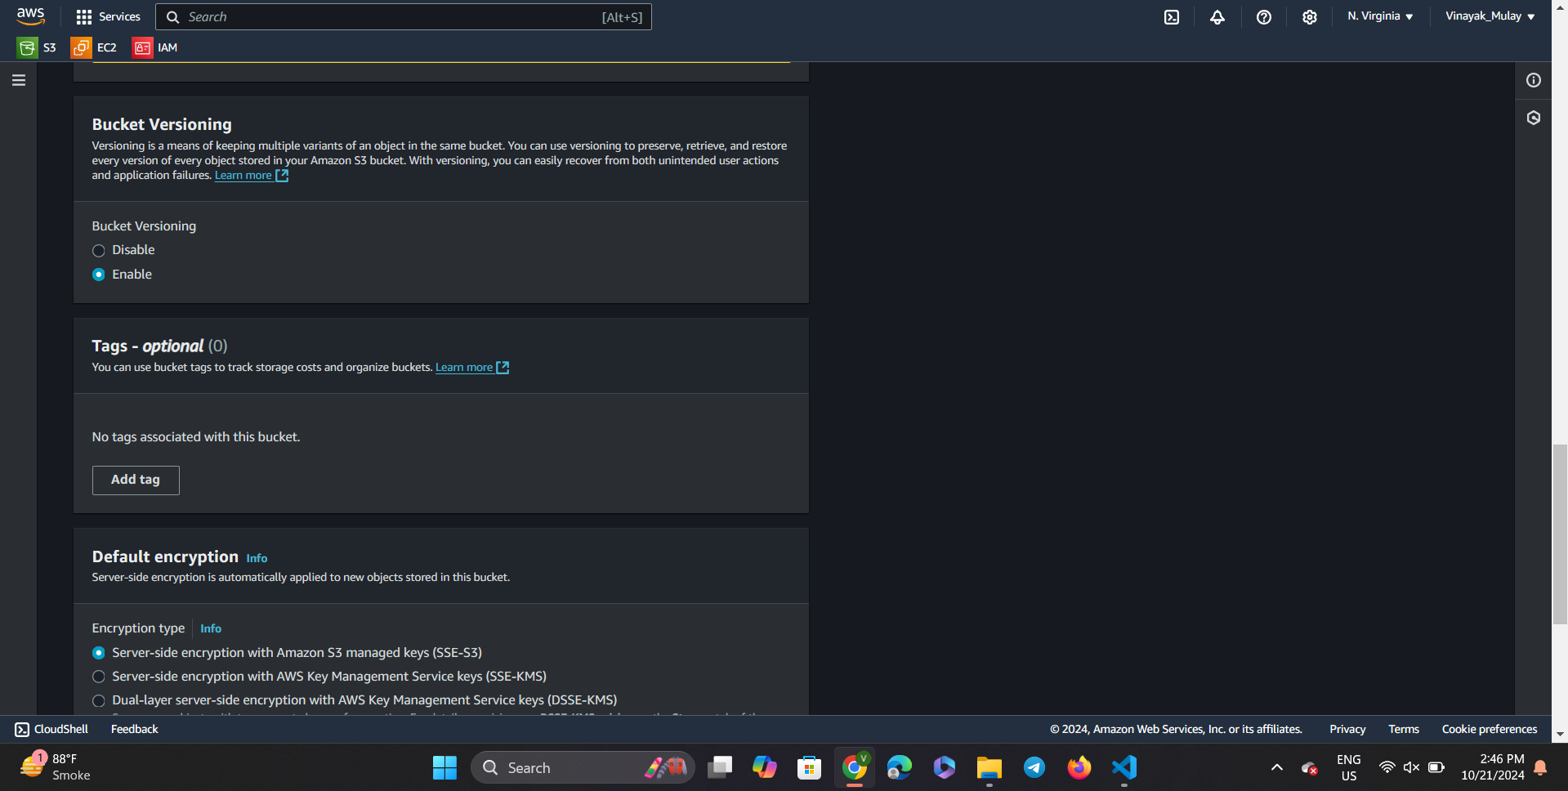

Step 8) Do not change any default setting and click on the create bucket button.

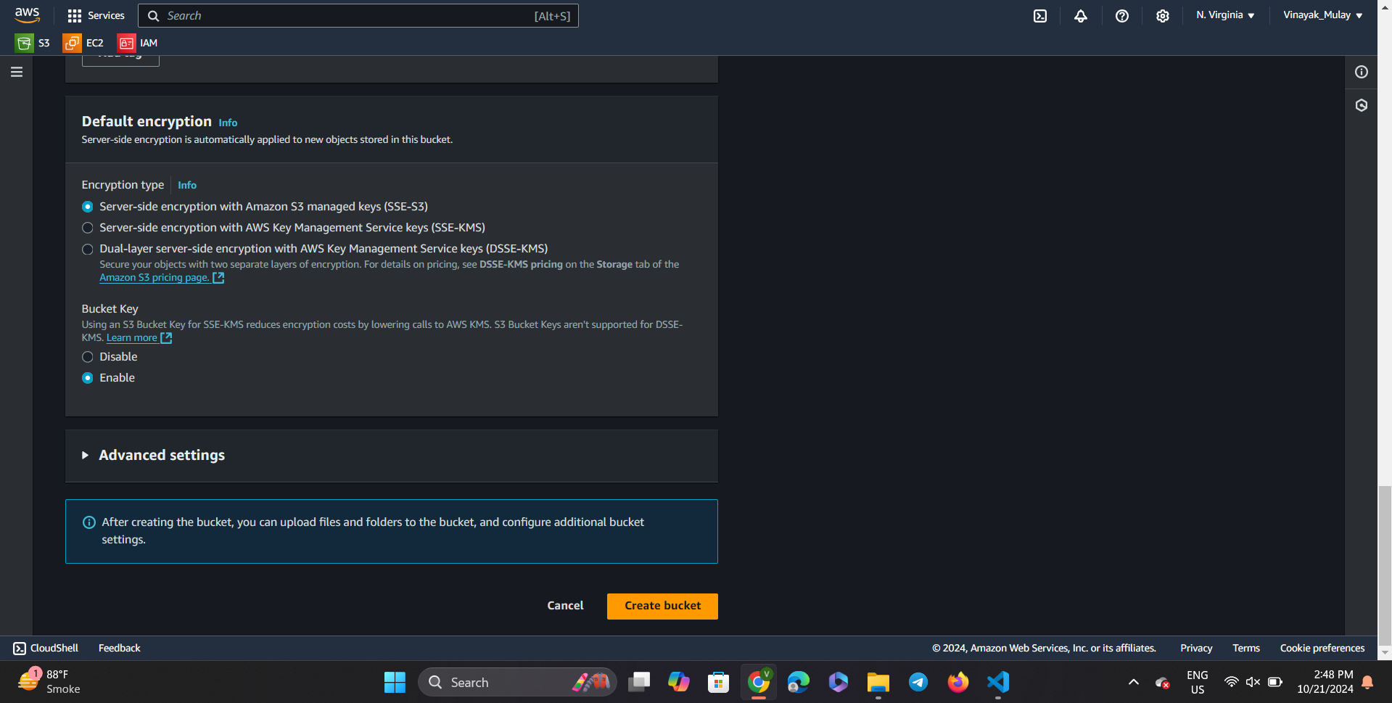

Step 9) Our bucket has been created successfully.

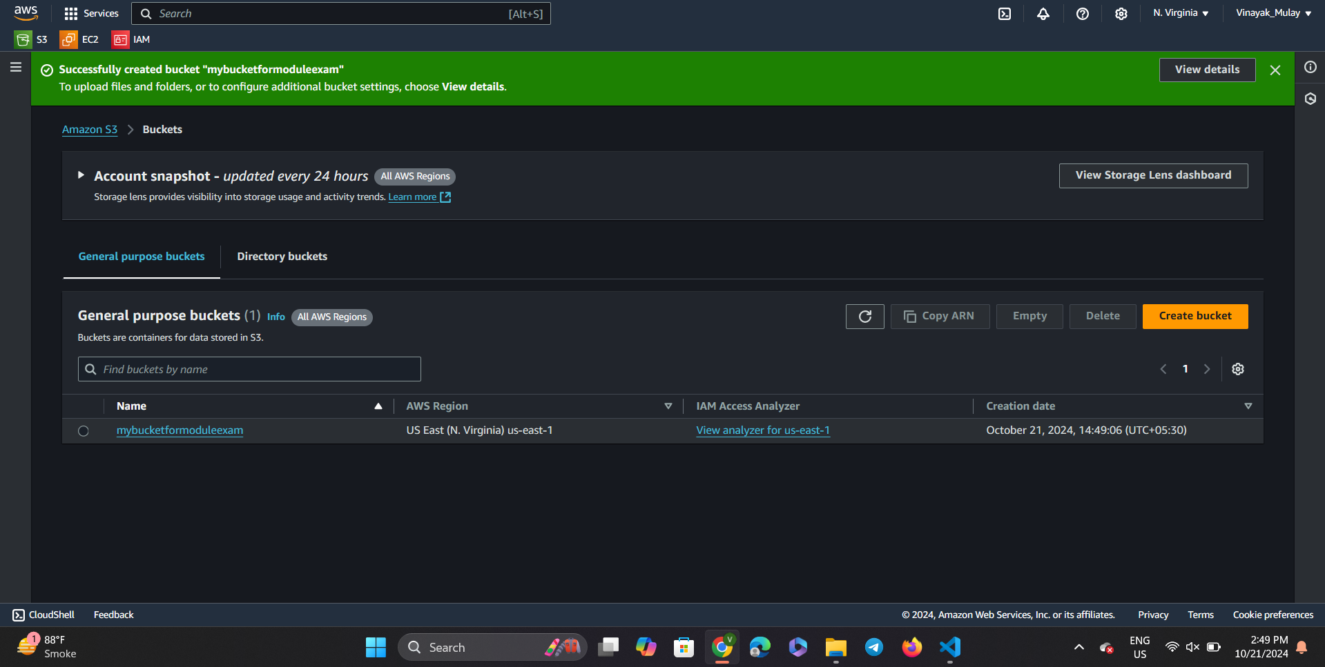

Step 10) As we can see our fresh bucket is empty, we will add the required HTML file to it further.

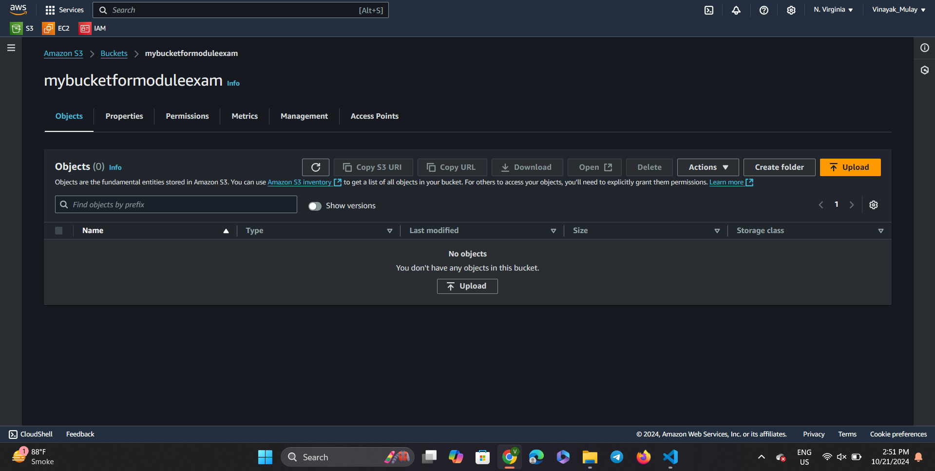

Step 11) Click on the upload button in the center of the screen.

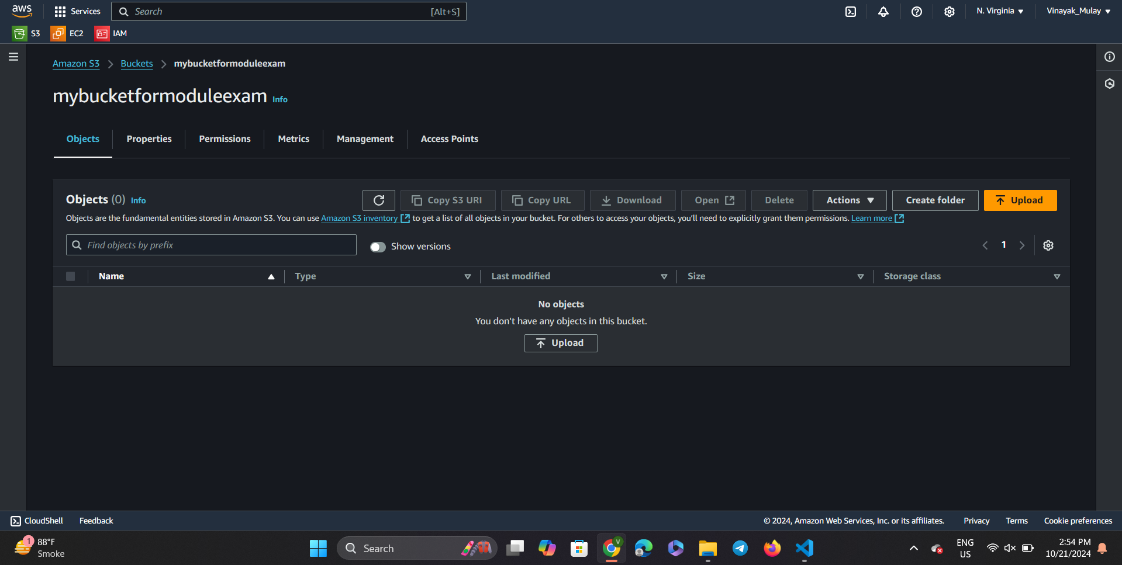

Step 12)

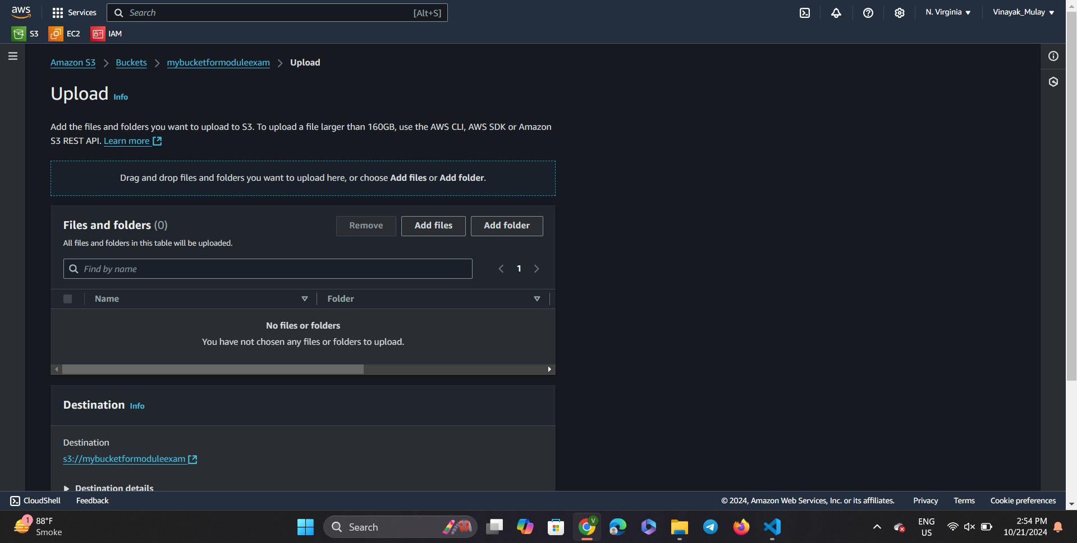

Step 13) By clicking on add files we get to browse the files to upload on our fresh bucket.

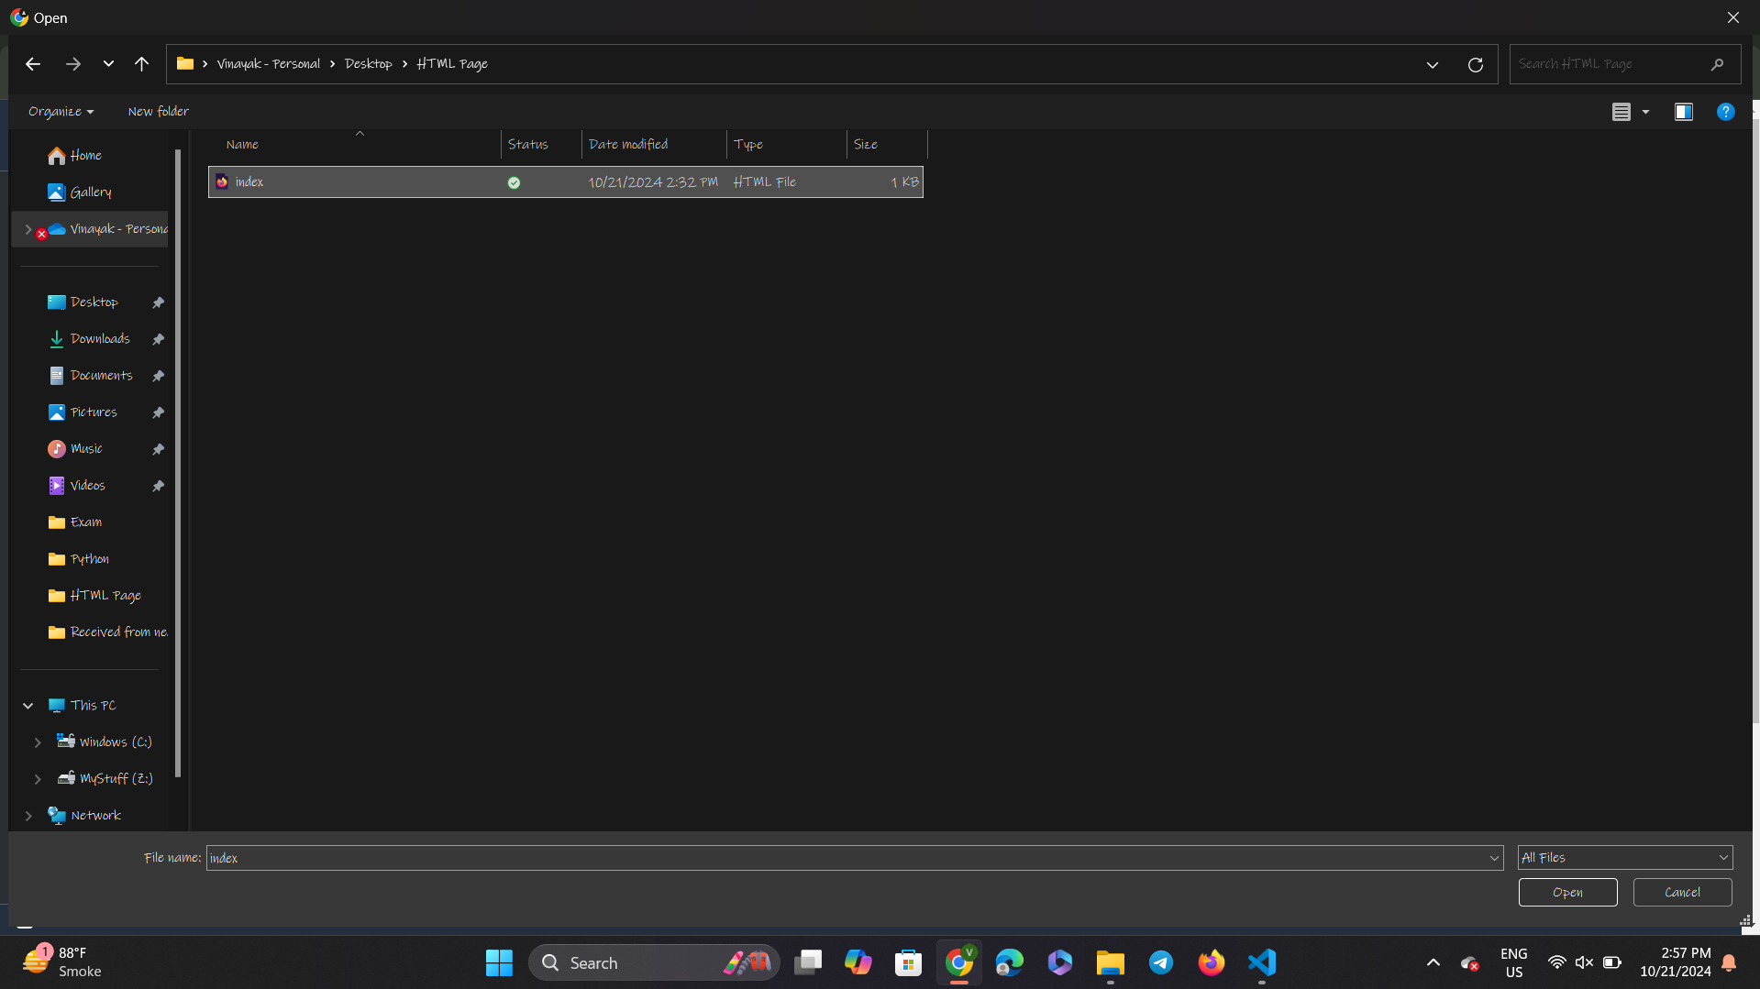

Step 14) We have successfully uploaded our html file to our bucket.

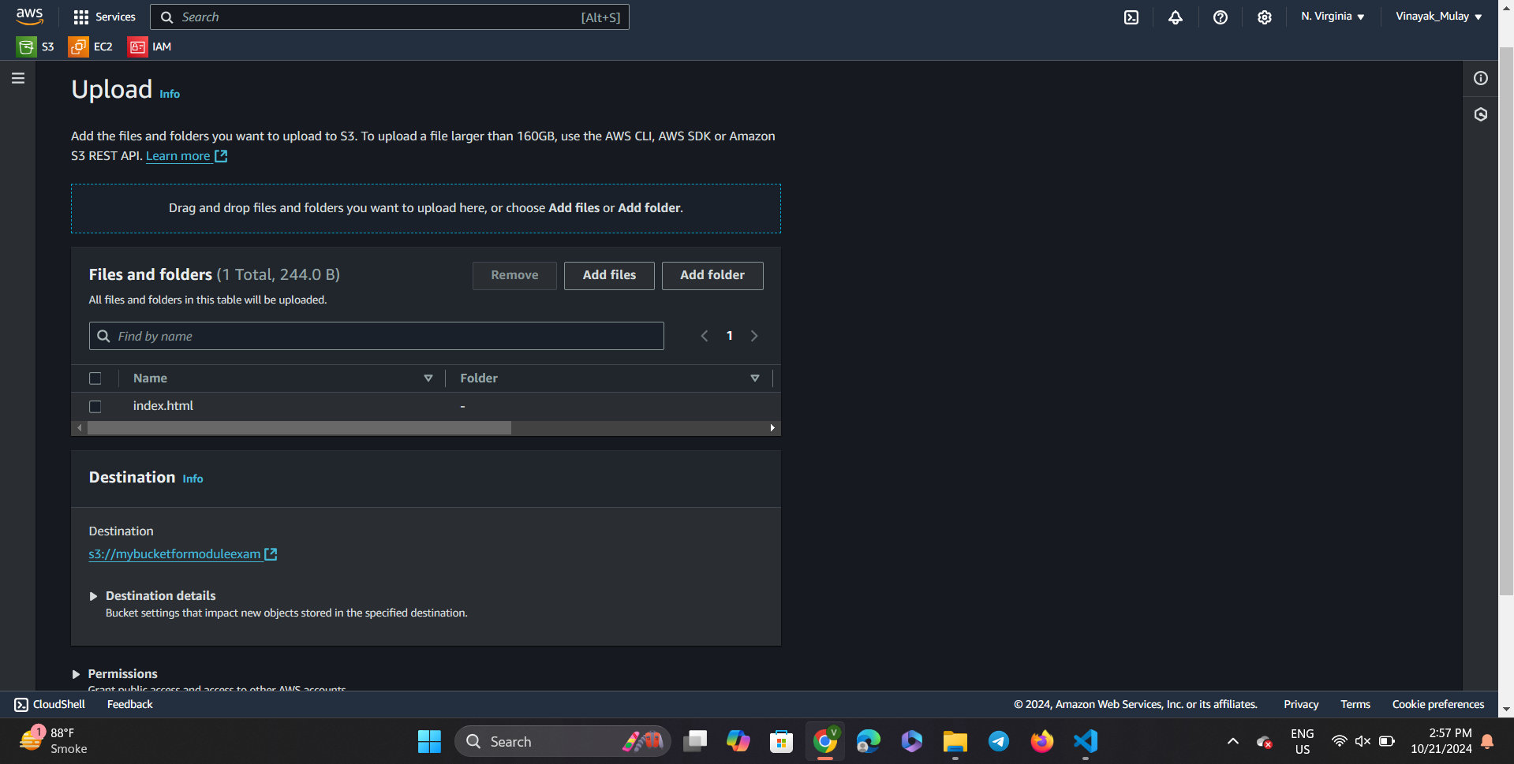

Step 15) Scroll down and click on upload.

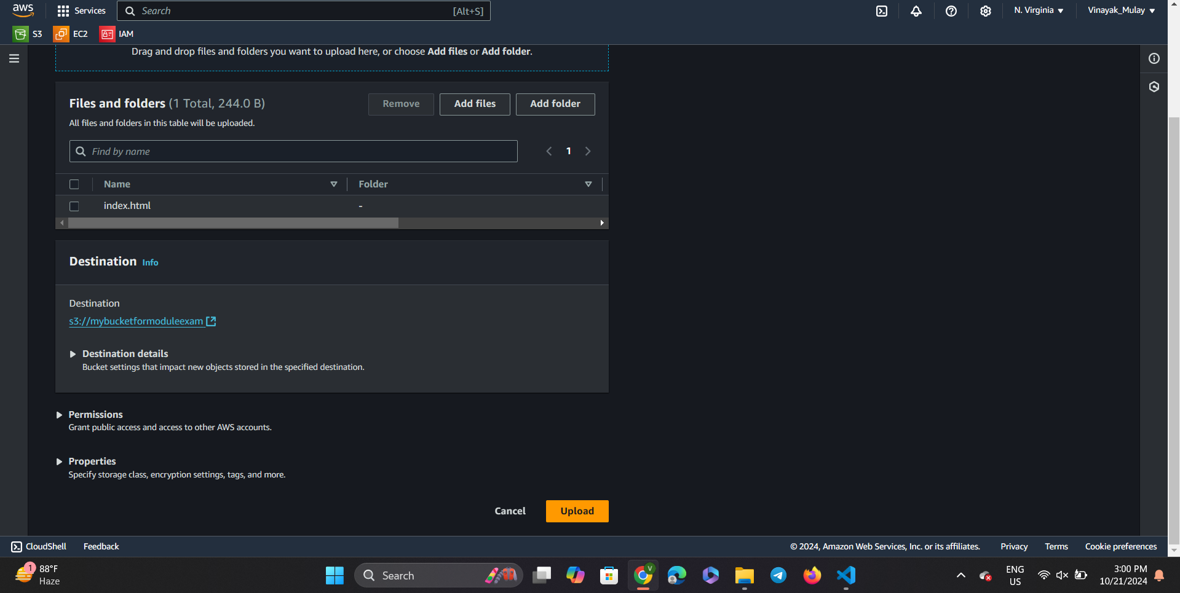

Step 16) Our file has been successfully uploaded on the bucket.

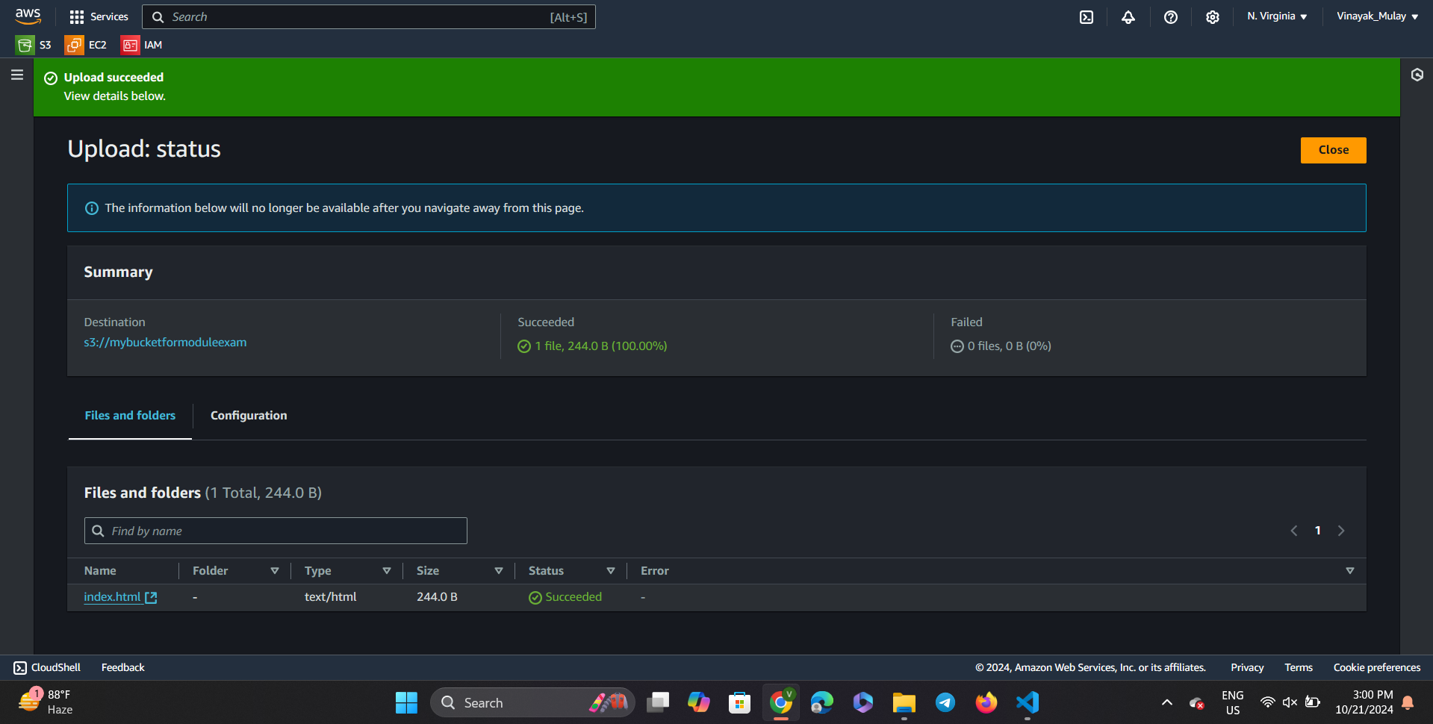

Step 17) Now we get back to S3 buckets page.

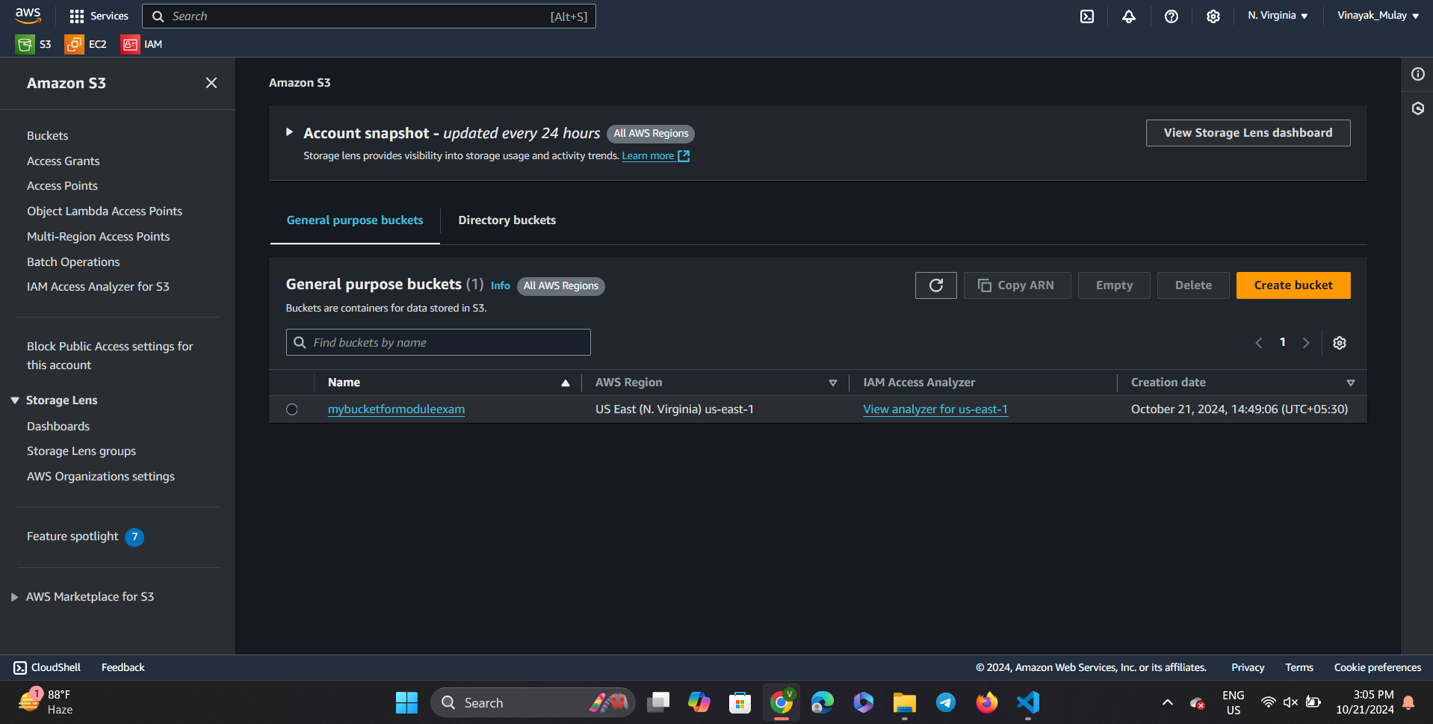

Step 18) Click on the name of the bucket, and we can see that the index.html file has been uploaded to our new bucket.

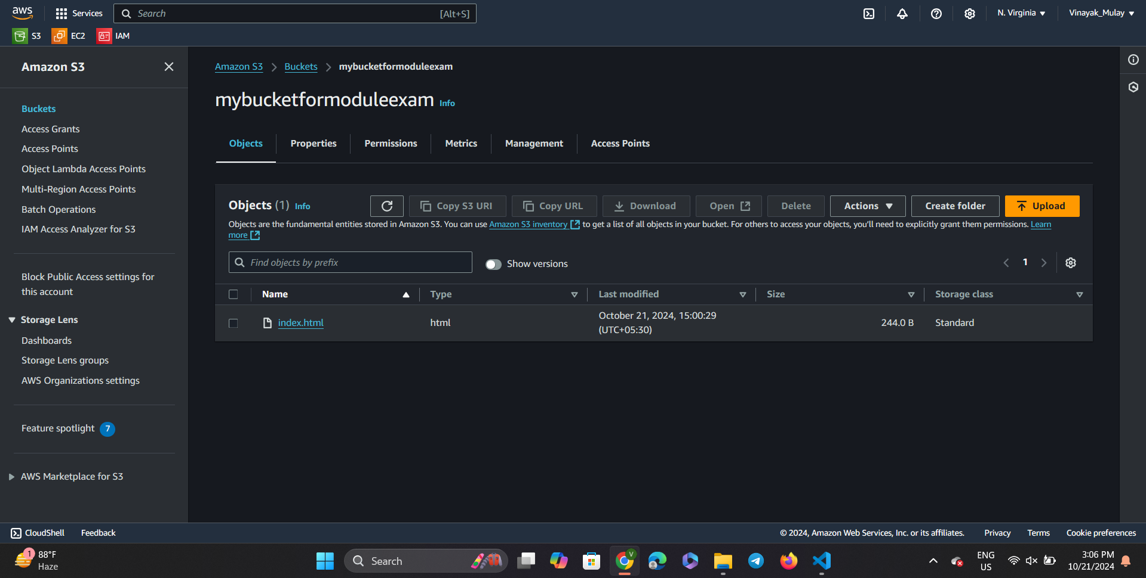

Step 19) When we select the index.html file and click on the open button given on the top of the objects bar.

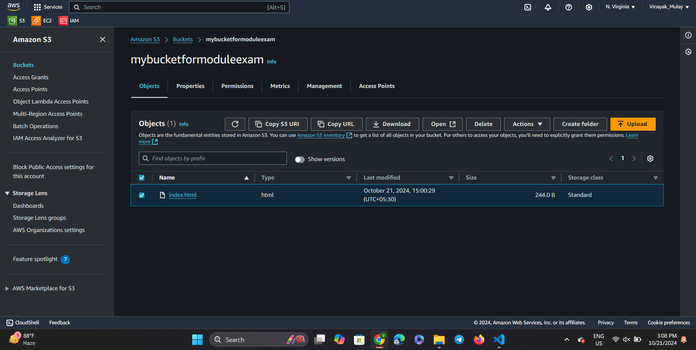

Step 20) And the given HTML file is showing the desired message as the output.

